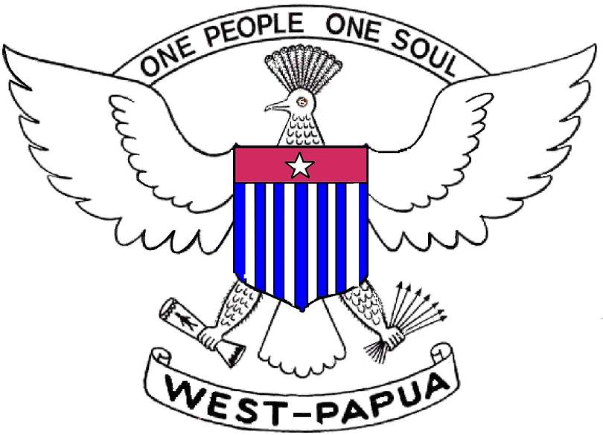
The Koteka Tribal Assembly
(Dewan Musyawarah Masyarakat Adat Koteka - Demmak)
Betrayed but NOT Defeated!

Dear Friends around the world,

The right to self-determination is the fundamental right of a people and a state.

I am writing to ask you to take part in a crucially important campaign to persuade the UN Secretary-General Kofi Annan to conduct an internal review of the UN's conduct in relation to the Act of 'Free' Choice in West Papua in 1968-1969'

The United Nations was under formal obligation to “advise, assist and participate” in an “act of self-determination in accordance with international practice” in West Papua by 1969. What took place became known as the “Act of ‘Free’ Choice”, which West Papuans now condemn as an “Act of No Choice”. The abysmal failure of the UN’s mission in West Papua condemned the West Papuan people to more than three decades of repression, massacres and the violation of their rights, a situation which continues to this day: for example, in November 2001, non-violent West Papuan leader Theys Eluay was assassinated.

At an International Solidarity Meeting in October 2001, in which solidarity groups, NGOs, and West Papuans participated, it was decided to submit a request to Kofi Annan to conduct a review of the UN’s conduct. One strong precedent for such a review is the review initiated by Kofi Annan in 1999 when he sought and gained permission from the UN Security Council to review the UN’s actions in relation to Rwanda in 1994.

A formal submission was presented to the UN Secretariat in New York on 26 March 2002. Country missions were lobbied on the same day, and an international campaign was formally launched.

The campaign is now supported by over 50 organisations and over 50 parliamentarians.

I attach a short briefing on the reasons for this call for a review.

I hope that your organisation will be willing to lend its support to this campaign, by:

1. agreeing to lend its name to this call for the UN to review its conduct in relation to the Act of 'Free' Choice in West Papua in 1968-1969;
2. by writing to Kofi Annan on your own letterhead (I attach a sample letter);
3. by actively participating in the campaign for this review.

If you wish to lend your organisation's name to this call, please cut and paste the following, fill in your name and contact details, and send by email to: skaroba@tribalnetworks.org or by fax to: +353 404 46400

++++++++++++++++++++++++++++++++++++++++++++++
Koteka Tribal Assembly – for Rights, Peace and Justice in West Papua
http://www.westpapua.org.uk/demmak, Email: koteka@westpapua.net
++++++++++++++++++++++++++++++++++++++++++++++

The Hon Kofi Annan
United Nations Secretary-General
UN Plaza
New York, NY 10017, USA
Fax: 001 212 963 2155; 963 7055, 963-4879
Email: sg@un.org ; ecu@un.org

The submission documentation, and updates on the campaign, are available at: http://westpapuaaction.buz.org/unreview

Should you wish to enquire further, please contact me.

Yours faithfully,

Sem Karoba (skaroba@tribanetworks.org)
Alliance of Papuan Students International Spokesperson
for Demmak and Papua Presidium Council

Rationale for call on Kofi Annan to review the UN's conduct in relation to the Act of
'Free' Choice in West Papua in 1968-1969'

Last November, the Papuan people of Indonesian-controlled West Papua (or Irian Jaya as it was re-named by Jakarta) buried Theys Eluay, the West Papuan leader who was leading a non-violent struggle for self-determination.

West Papua has been run by Jakarta since 1963. In 1969, Indonesia staged a declaration of loyalty to attempt to satisfy obligations under an international agreement to which it was a signatory to hold an “act of self-determination in accordance with international practice”. West Papuans have always insisted that the act was neither fair nor representative.

Both the UN Secretariat and the vast majority of UN member states had either rejected or ignored their claim. However in an unprecedented admission to the journalist Slobodan Lekic, retired UN Under-Secretary-General Chakravarthy Narasimhan has now said publicly that the whole operation was a “whitewash”. This admission by Narasimhan is profoundly significant because he was the senior UN Secretariat figure responsible for the organisation’s involvement in West Papua from 1962 to 1969.

To make sense of current West Papuan resistance to Indonesian rule it is necessary to understand why the Papuans were denied their right to self-determination and why it was that an Asian country ended up in control of this vast, resource-rich land and its Melanesian population. The answer to this lies not in the dubious merit of Jakarta’s claim to the territory, but rather in the Cold War politics of post-1945 Southeast Asia.

When the Netherlands finally granted Indonesian independence in 1949 they remained in neighbouring West Papua on the grounds that the indigenous inhabitants had nothing in common with the Indonesians. Instead, the Dutch began preparations for Papuan independence, initially in conjunction with Australia, which controlled the eastern half of the island. But while Australia’s colony became the independent state of Papua New Guinea in 1975, the West Papuans were to endure a very different fate.

Insisting that West Papua was his, Indonesian President Sukarno turned to the Soviets for arms and threatened to invade the Dutch colony. In 1962, under pressure from the US who wanted Sukarno appeased to entice him away from Moscow, the Dutch gave in. They agreed to sign an agreement with Jakarta handing West Papua over to a temporary UN administration, but only on condition that self-determination would take place, ''in accordance with international practice,'' within six years.

In the event, the UN pulled out seven months later without any consultation with the Papuans and handed them over to Indonesia. As one senior UN official commented at the time:

That there will ultimately be quite serious resistance to the
Indonesians is, I think certain, therefore from the point of view of
expediency it behoves the UN to depart as soon as the Indonesians
are in fact thick enough on the ground.

When a small UN team returned in 1968 to help Indonesia prepare for the promised act of self-determination, the Papuans had already experienced five years of Jakarta’s military rule. As one visiting American diplomat noted, the Indonesians had ''tried everything from bombing to shelling and mortaring, but a continuous state of semi-rebellion persists”.

Aware of their deep unpopularity, Jakarta declared in January 1969 that a referendum was impractical because the people were too ''primitive.'' Instead, they selected just over 1000 Papuans to act as representatives for the whole population.

Rather than protest, the UN chose to cooperate. As a consequence, in July and August 1969, Jakarta arranged for a selection of international diplomats, UN officials and journalists to bear witness as groups of Papuan “representatives” paraded in front of them unanimously declaring their love for Indonesia and their desire to join the Republic. It was in stark contrast to the UN-organised referendum in East Timor thirty years later.

Despite the farcical nature of Indonesia’s stage-management of the Act, there was little international interest. Writing in 1968 one British official commented:

I cannot imagine the US, Japanese, Dutch, or Australian governments putting at risk their economic and political relations with Indonesia on a matter of principle involving a relatively small number of very primitive peoples.

Another British diplomat in New York reported:

the great majority of United Nations members want to see this question cleared out of the way with the minimum of fuss as soon as possible...the [UN] Secretariat, whose influence could be important, appear only too anxious to get shot of the problem as quickly and smoothly as possible.

With minimal objection, the UN General Assembly simply voted in November 1969 to ‘take note’ of a UN report of the Papuan declaration of loyalty, and with that the UN washed its hands of responsibility for the West Papuan people.

Thirty-two years on, despite the best efforts of the international community, the issue has not gone away. At the same time, an estimated 100,000 West Papuans have died while their land and natural resources have been seized for the benefit of Indonesia and its multi-national partners. Nonetheless, now that the most senior UN official involved at the time has admitted on the record that West Papuan “self-determination” was a complete charade, it is time for Kofi Annan to revisit this question, both for the West Papuan people and for the credibility of the United Nations itself.

Further information and briefing material, including the full submission to the UN Secretariat is at: http://westpapuaaction.buz.org/unreview

(Name of NGO, address, contact details, email contact) support international calls on UN Secretary-General Kofi Annan to review the UN's conduct in relation to the Act of
'Free' Choice in West Papua in 1968-1969'

http://www.westpapua.net/docs/books/book0/un_wp.doc
http://www.westpapua.net/about/heroes/theys/
Summary of a Ph.D. thesis on the Role of the UN http://www.westpapua.net/docs/books/book0/un_wp.doc and a briefing article on the case: http://www.westpapua.net/docs/action/03/afc-briefing.doc

